**CS359 - Computer Network Lab**

**Lab 6**

Tarusi Mittal 1901CS65

Objective:

To see how DHCP (Dynamic Host Configuration Protocol) works. DHCP is an essential glue protocol that is used to configure your computer with an IP address, as well as other information.

* For this we will follow the following steps:

1. Open wireshark and click on start capture

2. Open command prompt and run the following three commands

1. Ipconfig /renew
2. Ipconfig /release
3. Ipconfig /renew

3. Close command prompt

4. Click save as in wireshark and click on stop capture

**Answer the following questions based on your examination of the DHCP fields for both the DHCP Request and DHCP Ack.**

**Question 1. How long is the Transaction ID field? Say whether it is likely that concurrent DHCP operations done by different computers will happen to pick the same Transaction ID.**

Answer:

The transaction Id is 4 bytes long. The phenomenon that the Concurrent DHCP operations done by a large number of computers will collide unless that number approaches 2^32 is not very possible.

**Question 2. What is the name of the field that carries the IP address that is being assigned to the client? You will find this field filled in on the DHCP Ack, as that message is completing the assignment.**

Answer:

The “Your (client) IP address” field carries the IP address being alloted to the client.

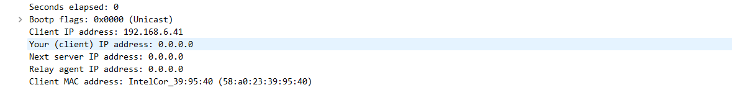

**Question 3. The first DHCP option is DHCP Message Type. What option value stands for this type? DHCP Requests will typically have a Client Identifier option. Look at the value of this option. How does it identify the client? Take a guess.**

Answer:

The option value of 53 is given to first DHCP message type

Its attributes are

1. Length: 1

2. DHCP: Request (3)



The client identifier usually caries the ethernet address of client itself

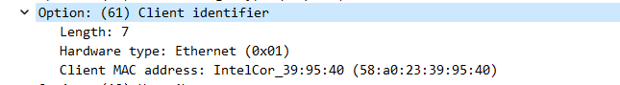

As you can see my ethernet address and the client address both are same



It is also possible to use some other kind of identifier like host name

**Question 4. DHCP Ack will typically have a Server Identifier Option. Look at the value of this option. How does it identify the server? Take a guess.**

Answer:

The Server Identifier usually carries the IP address of the DHCP server, but it is also possible to use some other kind of identifier.



On running ipconfig command we get the address which is the same as DHCP server identifier.



**Question 5. What option value stands for the Requested IP Address option? And for the IP Address Lease Time option?**

Answer:

The option value of 50 is given to the Requested IP Address and its value is the Ip address which is requests that is : 192.168.6.41

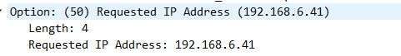

The option value of 51 stands for IP Address Lease Time.

Its values is: 3599s or 59 minutes, 59 seconds



**Question 6. How does the recipient of a DHCP message know that it has reached the last option?**

Answer:

The end option is used to determine the end of the DHPC message



**Answer the following questions by selecting a DHCP Request packet and looking at its UDP details in the middle Wireshark panel.**

**Question 1. What port number does the DHCP client use, and what port number does the DHCP server use?**

Answer:

The DHCP client uses UDP port 68

the DHCP server uses UDP port 67.

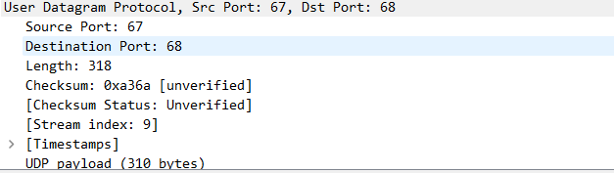

**Question 2. What source IP address is put on the Request message? It is a special value meaning “this host on this network” used for initialization.**

Answer:

The source IP address : 0.0.0.0



**Question 3. What destination IP address is put on the Request message? It is also a reserved value designed to reach the DHCP server wherever it is on the local network**

Answer:

The destination IP address : 255.255.255.255.

It is the broadcast address, which is used to connect to all the computers on the network



**Question 4. What source Ethernet address is put on the Request message, and what destination Ethernet address is put on the Request message? One of these addresses is a reserved address**.

Answer:

Source Ethernet address is 58 : a0 : 23 : 39 : 95 : 40

Destination Ethernet address is ff : ff : ff : ff : ff : ff

The Ethernet destination address is the reserved broadcast Ethernet address, so that the packet reaches all computers on the local network.

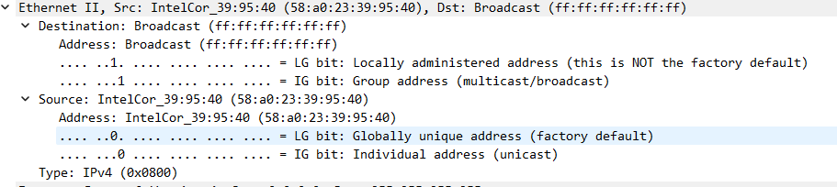

**Question 5. How does a computer work out whether a DHCP message it receives is intended as a reply to its DHCP Request message, and not a reply to another computer? Hint: If you are not sure then go over the fields you inspected previously**

Answer:

The usage of transaction ID by DHCP message starting from request to ACK helps the computer understand that message is intended as a reply to its request message or not



END